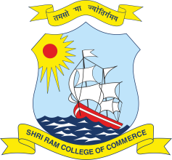 | SHRI RAM COLLEGE OF COMMERCE  University of Delhi, Maurice Nagar, Delhi – 110 007  Website: www.srcc.edu Phone: 27667905, 27666519

Date: 20.06.2020

Students Notice
(Regarding Last date for Examination Form)

Students who have so far not filled Examination Form are hereby advised to fill the same forthwith without any delay. It is further informed that the University of Delhi has extended the date for filling examination form till 22.06.2020.
Students are also advised to keep checking announcements at the website of the University of Delhi and the College regarding examination and academic matters.

PRINCIPAL

